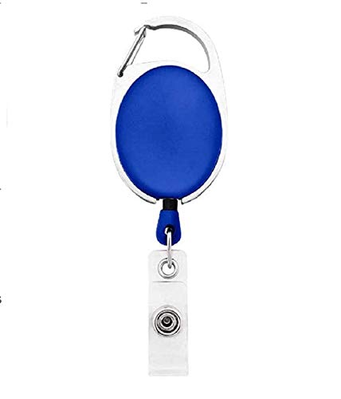



Angelia Cartee | 
Sales
02/21/2022
AB -ve
12345678

Questions / Queries – Drop an email to mailmukeshkala@gmail.com

